YISHUN JUNIOR COLLEGE

JC2 PRELIMINARY EXAMINATION 2010

CHEMISTRY 8872/01

HIGHER 1 24 August 2010
50 minutes

Paper 1 Multiple Choice

Additional materials: Multiple choice Answer Sheet

Data Booklet

YISHUN JUNIOR COLLEGE YISHUN JUNIOR COLLEGE YISHUN JUNIOR COLLEGE YISHUN JUNIOR COLLEGE YISHUN JUNIOR COLLEGE
YISHUN JUNIOR COLLEGE YISHUN JUNIOR COLLEGE YISHUN JUNIOR COLLEGE YISHUN JUNIOR COLLEGE YISHUN JUNIOR COLLEGE
YISHUN JUNIOR COLLEGE YISHUN JUNIOR COLLEGE YISHUN JUNIOR COLLEGE YISHUN JUNIOR COLLEGE YISHUN JUNIOR COLLEGE
YISHUN JUNIOR COLLEGE YISHUN JUNIOR COLLEGE YISHUN JUNIOR COLLEGE YISHUN JUNIOR COLLEGE YISHUN JUNIOR COLLEGE
YISHUN JUNIOR COLLEGE YISHUN JUNIOR COLLEGE YISHUN JUNIOR COLLEGE YISHUN JUNIOR COLLEGE YISHUN JUNIOR COLLEGE
YISHUN JUNIOR COLLEGE YISHUN JUNIOR COLLEGE YISHUN JUNIOR COLLEGE YISHUN JUNIOR COLLEGE YISHUN JUNIOR COLLEGE
YISHUN JUNIOR COLLEGE YISHUN JUNIOR COLLEGE YISHUN JUNIOR COLLEGE YISHUN JUNIOR COLLEGE YISHUN JUNIOR COLLEGE
YISHUN JUNIOR COLLEGE YISHUN JUNIOR COLLEGE YISHUN JUNIOR COLLEGE YISHUN JUNIOR COLLEGE YISHUN JUNIOR COLLEGE
YISHUN JUNIOR COLLEGE YISHUN JUNIOR COLLEGE YISHUN JUNIOR COLLEGE YISHUN JUNIOR COLLEGE YISHUN JUNIOR COLLEGE
YISHUN JUNIOR COLLEGE YISHUN JUNIOR COLLEGE YISHUN JUNIOR COLLEGE YISHUN JUNIOR COLLEGE YISHUN JUNIOR COLLEGE
YISHUN JUNIOR COLLEGE YISHUN JUNIOR COLLEGE YISHUN JUNIOR COLLEGE YISHUN JUNIOR COLLEGE YISHUN JUNIOR COLLEGE
YISHUN JUNIOR COLLEGE YISHUN JUNIOR COLLEGE YISHUN JUNIOR COLLEGE YISHUN JUNIOR COLLEGE YISHUN JUNIOR COLLEGE
YISHUN JUNIOR COLLEGE YISHUN JUNIOR COLLEGE YISHUN JUNIOR COLLEGE YISHUN JUNIOR COLLEGE YISHUN JUNIOR COLLEGE
YISHUN JUNIOR COLLEGE YISHUN JUNIOR COLLEGE YISHUN JUNIOR COLLEGE YISHUN JUNIOR COLLEGE YISHUN JUNIOR COLLEGE
YISHUN JUNIOR COLLEGE YISHUN JUNIOR COLLEGE YISHUN JUNIOR COLLEGE YISHUN JUNIOR COLLEGE YISHUN JUNIOR COLLEGE
YISHUN JUNIOR COLLEGE YISHUN JUNIOR COLLEGE YISHUN JUNIOR COLLEGE YISHUN JUNIOR COLLEGE YISHUN JUNIOR COLLEGE
YISHUN JUNIOR COLLEGE YISHUN JUNIOR COLLEGE YISHUN JUNIOR COLLEGE YISHUN JUNIOR COLLEGE YISHUN JUNIOR COLLEGE
YISHUN JUNIOR COLLEGE YISHUN JUNIOR COLLEGE YISHUN JUNIOR COLLEGE YISHUN JUNIOR COLLEGE YISHUN JUNIOR COLLEGE
YISHUN JUNIOR COLLEGE YISHUN JUNIOR COLLEGE YISHUN JUNIOR COLLEGE YISHUN JUNIOR COLLEGE YISHUN JUNIOR COLLEGE


READ THESE INSTRUCTIONS FIRST

Write in soft pencil.
Do not use staples, paper clips, highlighters, glue or correction fluid.
Write your name and CTG on the OMS form and shade your register number.

There are 30 questions on this paper. Answer all questions. For each question there are
4 possible answers A, B, C and D.
Choose the one you consider correct and record your choice in soft pencil on the OMS.

Read the instructions on the Answer Sheet very carefully.

Each correct answer will score one mark. A mark will not be deducted for a wrong answer. Any rough working should be done in this question paper.

This question paper consists of 14 printed pages

Section A
For each question there are four possible answers, A, B, C, and D. Choose the one you consider to be correct.

1 | The diagram shows the mass spectrum of a sample of zinc. Calculate the relative atomic mass of zinc.  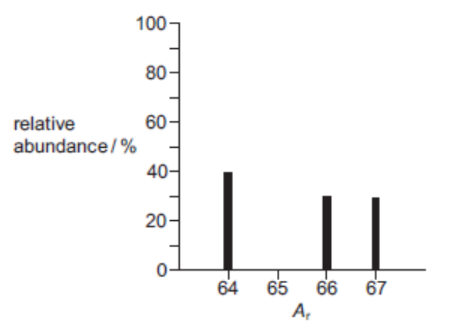
 | A | 65 | B | 65.25 | C | 65.5 | D | 65.66

2 | A sample of the hydrocarbon C₆H₁₂ is completely burned in dry oxygen and the products are collected as shown.  [Ar : H, 1.0 ; C, 12.0 ; O, 16.0]  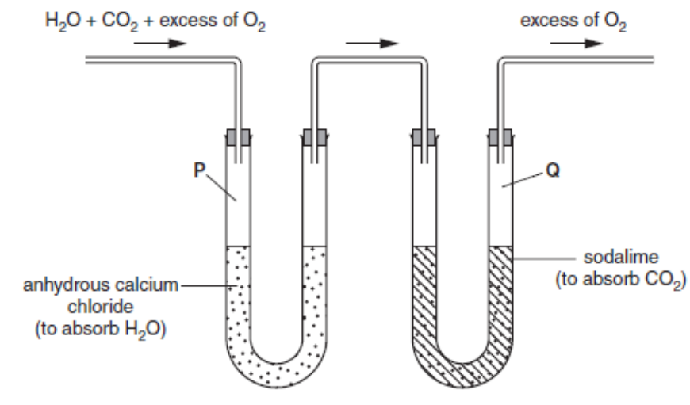
 | The increases in mass of the collecting vessels P and Q of the apparatus are M_{P} and M_{Q}, respectively. What is the ratio M_{P} / M_{Q}?
 | A | 2.4 | C | 1.2
 | B | 0.82 | D | 0.41

3 | The bond angles in the PH₃ molecule are likely to be
 | A | 90° | C | 109°
 | B | 104° | D | 120°

4 | A weedkiller can be prepared by heating a bleach solution.  3NaClO → 2NaCl + NaClO₃  bleach weedkiller  What are the oxidation states of chlorine in these three compounds?
 | A | −1 | −1 | +5
 | B | +1 | −1 | +5
 | C | +1 | −1 | +7
 | D | +2 | +1 | +7

5 | In an experiment, 0.00130 mole of a metallic salt reacted completely with 20.80 cm³ of 0.0250 mol dm⁻³ MnO₄⁻.  The half equation for the reduction of MnO₄⁻ is shown below:  MnO₄⁻ + 8H⁺ + 5e → Mn²⁺ + 4H₂O  Given the final oxidation number of the metal in the salt was +5, what would the original oxidation number of the metal be?
 | A | +1
 | B | +2
 | C | +3
 | D | +4

6 | The sketch below shows the variation of first ionisation energy with proton number for six elements of consecutive proton numbers between 1 and 18 (H to Ar).  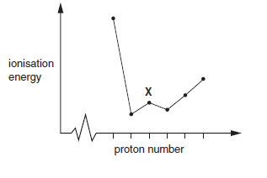
 | What is the identity of element X?
 | A | Mg | B | Al | C | Si | D | P

7 | What is the order of increasing energy of the listed orbitals in the atom of titanium?
 | A | 3s 3p 3d 4s
 | B | 3s 3p 4s 3d
 | C | 3s 4s 3p 3d
 | D | 4s 3s 3p 3d

8 | Hydrogen bonding can occur between molecules of methanal, HCHO, and molecules of liquid Y. What could liquid Y be?
 | A | CH₃CO₂CH₃
 | B | CH₃COCH₃
 | C | CH₃CHO
 | D | CH₃CH₂OH

9 | The diagram represents the reaction pathway for the following reaction.
W (g) + X (g) → Y (g) + Z (g)

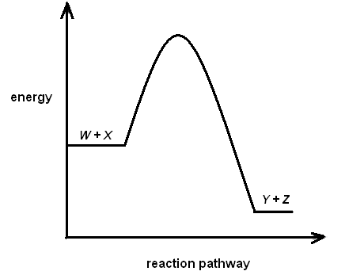

What statement can be made about the reverse reaction:

Y (g) + Z (g) → W (g) + X (g)?

 | A | It will have a larger activation energy and a positive ΔH.
 | B | It will have a larger activation energy and a negative ΔH.
 | C | It will have a smaller activation energy and a positive ΔH.
 | D | It will have a smaller activation energy and a negative ΔH.

10 | For which of the following reactions does the value of ΔH^{θ}_{rxn} represent both a standard enthalpy change of combustion and a standard enthalpy change of formation of a substance?
 | A | 2S (s) + O₂ (g) → 2SO₂ (g)
 | B | S (g) + O₂ (g) → SO₂ (g)
 | C | S (s) + O₂ (g) → SO₂ (g)
 | D | SO (g) + O₂ (g) → SO₂ (g)

11 | The equilibrium constant, K_{c}, to form ethyl ethanoate from ethanol and ethanoic acid at 60ºC, is 4.00. The reaction is shown below:  C₂H₅OH + CH₃COOH ⇌ CH₃COOC₂H₅ + H₂O
 | When 1.00 mol each of ethanol and ethanoic acid are allowed to reach equilibrium at 60°C, what is the number of moles of ethyl ethanoate formed?
 | A | 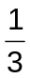 | B | 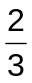 | C | 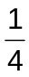 | D | 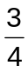

12 | Which statement concerning the equilibrium reaction below is true?  2CrO₄²⁻ (aq) + 2H⁺ (aq) ⇌ Cr₂O₇²⁻ (aq) + H₂O(l)
 | A | An increase in acid concentration will result in an increase in the concentration  of Cr₂O₇²⁻ (aq).
 | B | A redox reaction is taking place.
 | C | The addition of a catalyst will result in an increase in the concentration of  Cr₂O₇²⁻ (aq).
 | D | The equilibrium constant, K_{c}, has no units.

13 | Which of the following reagents can be mixed to form an acidic buffer?
 | A | HCN and NaCN
 | B | HNO₃ and NaNO₃
 | C | NaOH and NaCl
 | D | HCl and NaOH

14 | Which solid-line curve most accurately represents the distribution of molecular speeds in a gas at 500 K if the dotted-line curve represents the corresponding distribution for the same gas at 300 K?
 | A  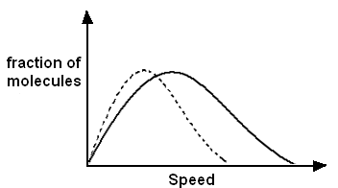 | C  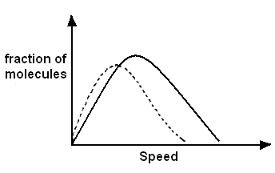
 | B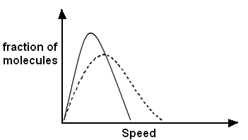 | D  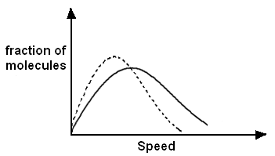

15 | Element R in period three of the periodic table forms an oxide which has a high melting point and is insoluble in water. Identify element R.
 | A | sodium
 | B | silicon
 | C | sulfur
 | D | chlorine

16 | Which one of the following chlorides of the elements of period 3 is a volatile liquid which is readily hydrolysed by water?
 | A | MgCl₂ | C | Al₂Cl₆
 | B | PCl₅ | D | SiCl₄
17 | Which of the following alkane is the most volatile?
 | A | 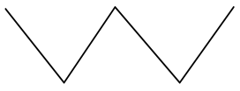 | C | 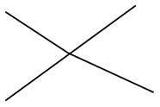
 | B | 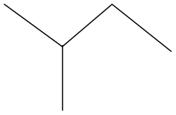 | D | 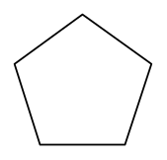

18 | Identify hybridisation state of carbons in the following molecule.  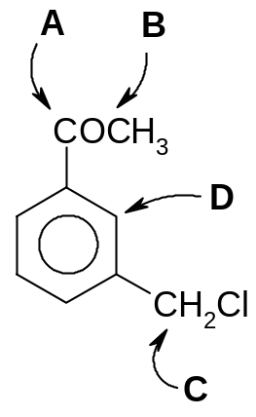
 |  | A | B | C | D
 | A | sp² | sp³ | sp³ | sp²
 | B | sp² | sp³ | sp² | sp³
 | C | sp³ | sp² | sp² | sp³
 | D | sp³ | sp² | sp³ | sp²

19. | Which compound cannot be obtained from propene in a single reaction?  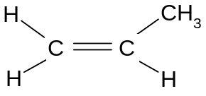  propenee
 | A | − C − C −  H  CH₃  H  H  H  H  − C − C −  H  CH₃  H  OH  H  OH | C | − C − C −  H  CH₃  H  CN  H  H
 | B |  | D | − C − C −  H  CH₃  H  Br  H  H

20. | Com Compound S has the structure shown below:  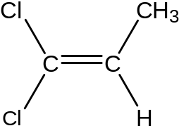
 | Which reagent, when reacted with compound S, causes the most damage to the ozone layer?
 | A | Steam | C | Cl₂
 | B | cold KMnO₄ | D | HCl

21. | Pheromone is a chemical compound used by the honeybee to attract other bees towards itself.  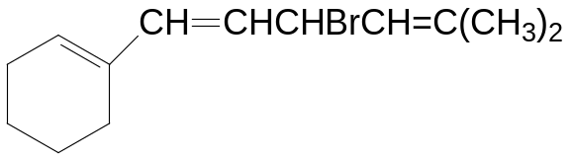  Pheromone
 | How many cis-trans isomers does this compound have?
 | A | 2 | C | 4
 | B | 3 | D | 6

22. | The compound shown below, ibuprofen, is a powerful painkiller.  CH₂  CO₂H  C  OH  CH₃  CH₃  CH  OH  CH₃
 | Which of the following reacts completely with one mole of ibuprofen?
 | A | 3 mol of SOCl₂ | C | 2 mol of PCl₅
 | B | 3 mol of HCl | D | 2 mol of NaOH

23. | The unsaturated diketone shown is excreted by the bombardier beetle.  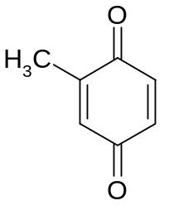  How does the compound above reacts with 2,4-dinitrophenylhydrazine reagent  (2,4-DNPH), Tollen’s reagent and Fehling’s reagent?  2,4-DNPH Tollen’s Fehling’s
 | A | negative | negative | negative
 | B | positive | negative | negative
 | C | positive | positive | negative
 | D | positive | positive | positive

24. | A halogen compound T gave little or no precipitate when boiled under reflux with ethanolic silver nitrate. Which of the following formulae is likely to be T?
 | A | CH₃CHClCH₂CH₃
 | B | 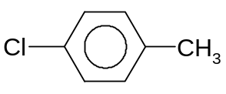
 | C | 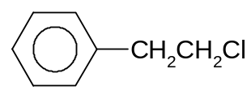
 | D | CH₃CH₂COCl

25 | A student obtained ethene from ethanol by carrying out an experiment using the following set-up.  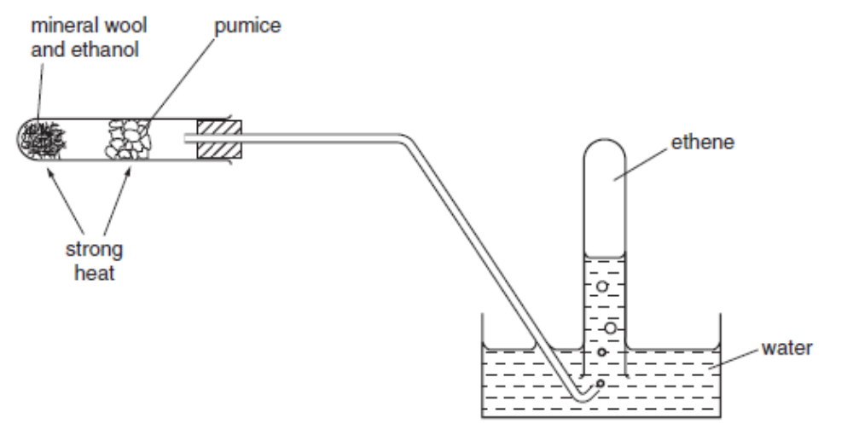
 | What type of reaction takes place on the hot pumice?
 | A | combustion
 | B | reduction
 | C | elimination
 | D | substitution

Section B

For each of the questions in this section, one or more of the three numbered statements 1 to 3 may be correct.

Decide whether each of the statements is or is not correct (you may find it helpful to place a tick against the statements that you consider to be correct).

The responses A to D should be selected on the basis of

A | B | C | D
1, 2 and 3 are correct | 1 and 2 only are correct | 2 and 3 only are correct | 1 only is correct

No other combination of statements is used as a correct response.

26 | Which pairs of compounds contain one that is giant ionic and one that is simple molecular?
 | 1 | Al₂O₃ and Al₂Cl₆
 | 2 | SiO₂ and SiCl₄
 | 3 | P₄O₁₀ and PCl₃

27 | k₁  Given, reactant ⇌ products  k₋₁  Which of the following changes will cause both of the rate constants, k₁ and k₋₁ to increase?
 | 1 | Introducing a catalyst.
 | 2 | Heating the equilibrium mixture.
 | 3 | Increasing the concentrations of the reactants.

28 | The lattice energy of an ionic solid U^{n+}V^{n−} is dependent on
 | 1 | the lattice structure of UV.
 | 2 | charges on the ions U^{n+} and V^{n−}.
 | 3 | ionic radii of U^{n+} and V^{n−}.

29. | Vitamin A has the structure  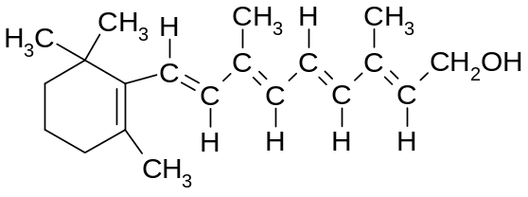  It is likely that this substance will
 | 1 | decolorise bromine water.
 | 2 | react with sodium carbonate solution.
 | 3 | react with aqueous sodium hydroxide.

30. | Below are the structures of compound X and Y:  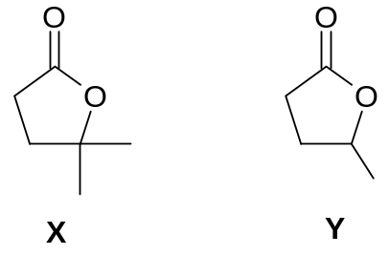  Which sets of reagents and conditions can be used to distinguish between compounds X and Y?
 | 1 | Acidified KMnO₄, reflux.
 | 2 | Aqueous alkaline iodine, heat.
 | 3 | 2,4-dinitrophenylhydrazine.

